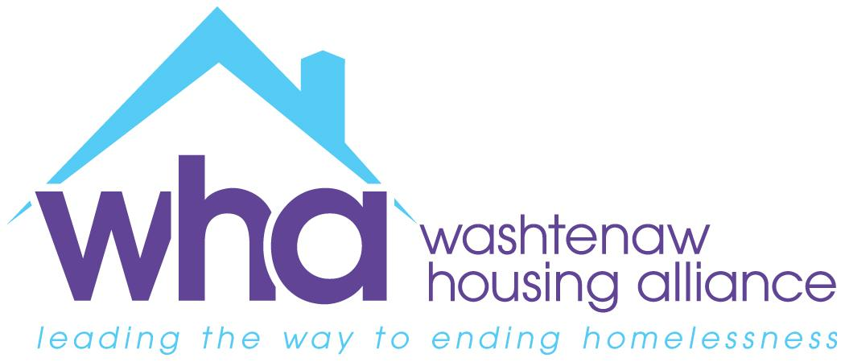
Source of Income Protections Summary
January 2022

Why Source of Income Protections are Needed

- Here (link) is a two-page summary from the Michigan Coalition Against Homelessness (MCAH) about Source of Income (SOI) Discrimination and why protections are needed for renters using any type of housing/rental assistance, such as a Housing Choice Voucher (HCV).
  - Currently, in areas without SOI protections where some landlords refuse to accept housing vouchers, voucher holders find it difficult to successfully find and lease housing and are oftentimes forced to return vouchers back to public housing authorities because they cannot find a landlord to accept them within the program’s allotted time.
  - In surveying Michigan homelessness service providers in 2018, MCAH learned that 44% of all respondents reported that landlords in their community will not rent to HCV holders.
- To note: SOI protections do NOT mandate landlords’ participation in the HCV Program, or any other rental assistance program. Landlords are free to not rent to voucher holders, so long as they do so on some non-discriminatory grounds.
- A study prepared for the U.S. Department of Housing & Urban Development (HUD) Office of Policy Development and Research found that source of income laws are associated with higher utilization of housing vouchers and with voucher holders moving to higher opportunity areas (Source: The Impact of Source of Income Laws on Voucher Utilization and Locational Outcomes by Lance Freeman, Columbia University, February 2011, link).

Source of Income Protections In Michigan Communities
As of August 2021, ten (10) municipalities in the state of Michigan have established source of income protections that prohibit discrimination against renters based on the source(s) of their income (Source: https://www.prrac.org/pdf/AppendixB.pdf). The municipalities with source of income (SOI) protections in Washtenaw County include the City of Ann Arbor (link) and City of Ypsilanti (link).
Municipality | Date Enacted | Definition of SOI in Ordinances
Ann Arbor (link) | Enacted 1978; Amended 2020. | Any lawful source of money paid directly to an individual or family or indirectly on behalf of an individual or family, including, but not limited to:  (a) Money derived from any lawful profession or occupation.  (b) Money derived from any contract, agreement, loan, or settlement; from any court order, such as court-ordered child support or alimony; from any gift or bequest; or from any annuity or life insurance policy.  (c) Money derived from any benefit or subsidy program, including, but not limited to, any housing assistance, such as Housing Choice Vouchers, Veterans Affairs Supportive Housing (VASH) Vouchers, or any other form of housing assistance payment or credit whether or not paid or attributed directly to a landlord; public assistance; emergency rental assistance; veterans benefit; Social Security or other retirement program; supplemental security income; or other program administered by any federal, state, or local agency or nonprofit entity. Any monthly housing assistance administered by any federal, state, or local agency or nonprofit entity shall be treated as income in the amount of 3x the value of that monthly rental assistance.
Ypsilanti (link) |  | It is the intent of the city that no person be denied the equal protection of the laws; nor shall any person be denied the enjoyment of their civil or political rights or be discriminated against because of actual or perceived race, color, religion, national origin, immigration status, sex, sexual orientation, gender identity, gender expression age, marital status, disability status, familial status, educational association, source of income, height or weight, or felony conviction (unless there is a direct relationship between the conviction offense and the housing, the job, the opportunity or unless hiring or accepting the person would create an unreasonable risk to property or safety).  Income means, without limitation, any of the following:  (1)Commissions, earnings, salaries, wages, and other income due or to be due in the future to an individual from his employer and successor employers.  (2)A payment due or to be due in the future to an individual from a profit-sharing plan, a pension plan, an insurance contract, an annuity, social security, unemployment compensation, supplemental unemployment benefits, or worker's compensation.  (3)An amount of money that is due to an individual as a debt of another individual, partnership, association, or private or public corporation, the United States or a federal agency, the state or a political subdivision of the state, another state, or another legal entity that is indebted to the individual.  (4)Housing vouchers issued to an individual by the government of the United States, a federal agency, the State of Michigan, or any political subdivision thereof. This shall include, without limitation, vouchers issued by the United States Department of Housing and Urban Development pursuant to 42 USC §1437f.  (5)Student loans, grants, or scholarships provided to an individual by any legal entity.

