FEATURING

Alliance President and CEO, Nan Roman | Secretary of Housing and Urban Development, Ben Carson | Ranking Member of the House Financial Services Committee, Congresswoman Maxine Waters

WITH WORKSHOPS ON

Affordable housing
Advocacy
Rapid rehousing
Healthcare
Early childhood education & development
Veteran homelessness
Youth & family homelessness
Racial inequality

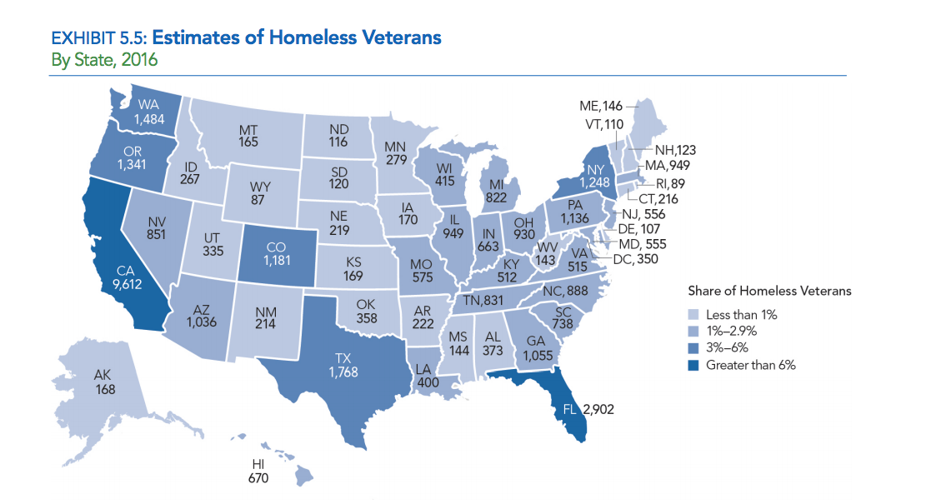

Workshop I: 1.08 Jump Start Your System to End Veteran Homelessness

Maura McCauley, City of Chicago Dept. of Family & Support Services |
Tom Albanese, Community Shelter Board | Mary Simons, Open Doors Homeless Coalition

In a lot of programs, system processes are inconsistent or missing. We need to make it our priority to...
- Use data to identify and hone in on specific areas of improvement
- Rebuild partnerships and re-engage with system-level stakeholders
Once we have a comprehensive community plan in place...
- Track performance
- Monitor system entries/exits
- Standardize screenings

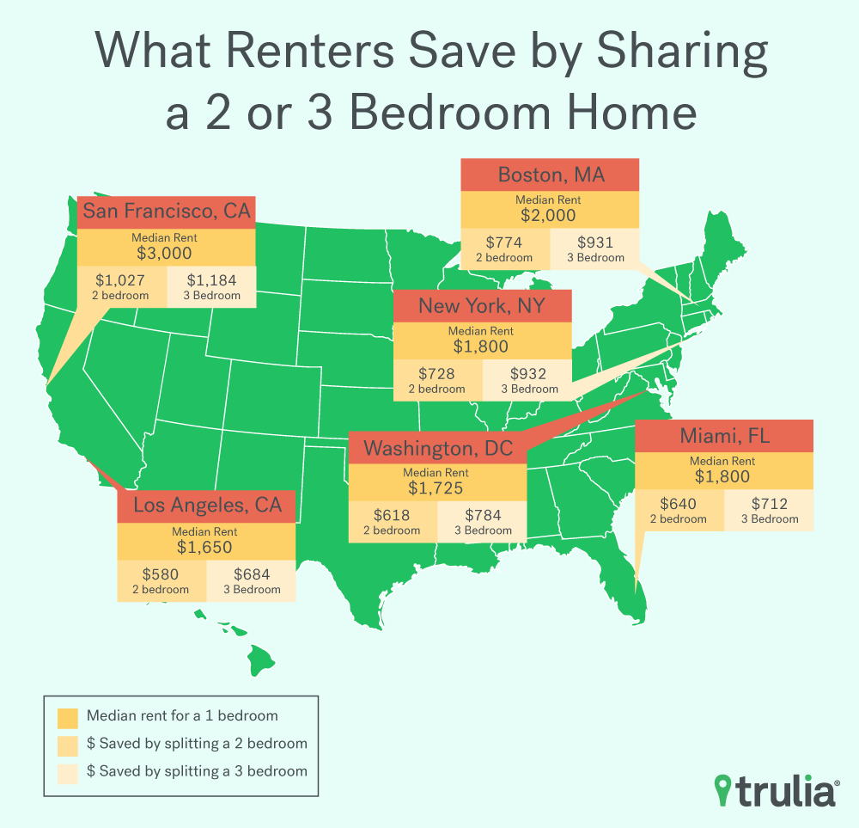

Workshop 4.14 The Scoop on Roommates and Shared Housing
Meghann Cotter, Micah Ministries | Kris Freed, LA Family Housing | Lorena McDowell, Northern Virginia Family Service | Bill Motsavage, Valley Youth House

Living with a roommate makes housing more affordable. Once people know their options in shared housing, it’s our job to make sure things run smoothly by…

- Using technology or an assessment to match roommates
- Setting guidelines and drawing up contracts
- Determining budget and division of expenses
- Communicating with landlord
- Checking in frequently
- Creating an exit strategy for tenants

